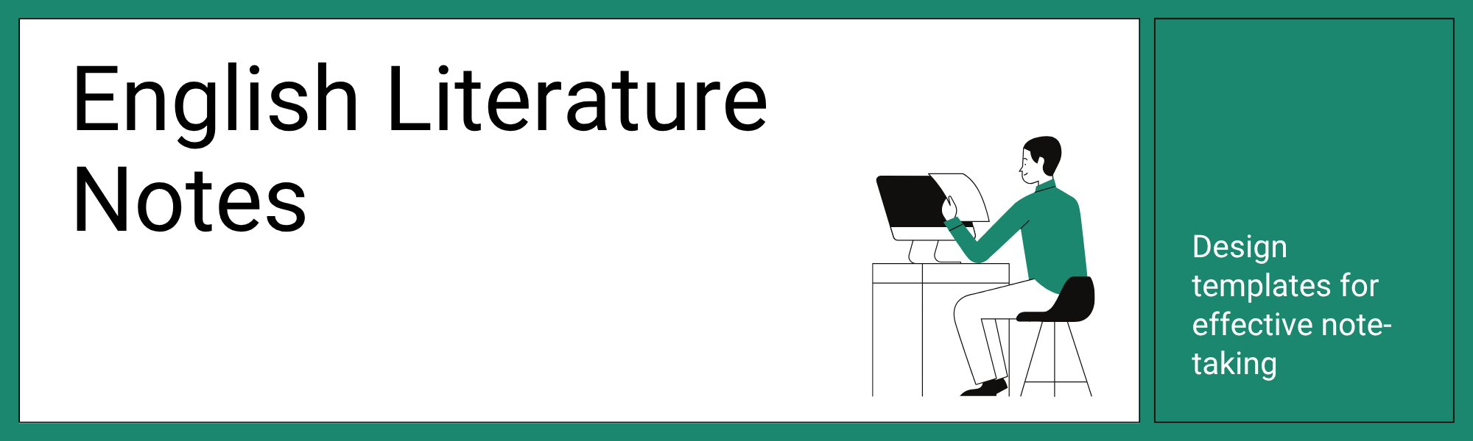
🎯 In this activity, you will design and organize templates for literature notes. You'll identify key elements such as plot, character analysis, theme, and literary devices, ensuring clarity and usefulness for future study and revision.
📖 Read the Given Text
Read the following passage.
In a small village nestled between rolling hills, lived a young woman named Elara. Elara was known for her kindness and her love for old books. One day, while exploring the attic of her grandmother's house, she discovered a hidden journal. The journal belonged to a traveler who had visited the village a century ago. As Elara read through the faded pages, she became captivated by the traveler's tales of faraway lands and mythical creatures. The journal spoke of a hidden portal, located somewhere in the village, that led to a world of endless possibilities. Driven by curiosity and a thirst for adventure, Elara decided to embark on a quest to find the portal. Along her journey, she encountered mysterious figures, solved ancient riddles, and faced daunting challenges. With each step, Elara's determination grew stronger, and she realized that the greatest adventure lies not in the destination, but in the journey itself.
📍This passage was created using AI.
🧐 Define Your Research Focus
Explore the following thematic options and choose a guiding question for your research:
- Character Analysis: How does Elara's personality drive the plot?
- Theme Identification: What are the central themes in the passage, and how are they explored?
- Literary Devices: What literary devices are used, and what impact do they have on the text?
Now, write down your research focus as a question:
[Write your research question here.]
❓ Research Questions
Follow the steps below to complete this section:
- Based on your research focus, create a central question that guides your analysis.
- Develop supporting questions that delve deeper into specific aspects of the passage.
- Use the table to organize your questions and thoughts.
Question Type | Your Thinking
Central Question
Supporting Question
+ Add a row or column
📚 Research and Analyze Sources
- Primary sources: These are original materials that provide firsthand accounts or direct evidence concerning a topic. They offer direct insights into the subject of your research (diary, interview, photograph, original record).
- Secondary sources: These sources analyze, interpret, or evaluate primary sources. They offer commentary and synthesis, providing a broader perspective on the topic (textbook, article, documentary).
- Tertiary sources: These sources compile and summarize information from primary and secondary sources. They provide an overview of the topic and can help you get started with your research (encyclopedia, database).
💡 Research Tip: When doing research, look for primary and secondary sources from different places. Read books, websites, and articles. Ask: Is this information true? Does it make sense? Use what you learn to answer your questions.
Source (Book, Website, Article, etc) | Information Found | Question Answered | Source Type (Primary, Secondary, or Tertiary)
+ Add a row or column
✍️ Synthesize Your Findings
Create a one-page infographic that includes the main idea, three evidence blocks, visuals, keywords, sources, and an optional extension.
Follow the steps below to complete your infographic:
- Identify the main idea or argument you want to convey.
- Gather evidence from your research to support your main idea.
- Select visuals, keywords, and sources to enhance your infographic.


🤔 Reflection
How has your understanding of English literature notes improved after completing this activity?
[Write your answer here.]
What challenges did you encounter while designing your literature notes template, and how did you overcome them?
How can you apply the skills you learned in this activity to future English literature assignments?
Teaching note
This was generated by AI to give you a head start — not the final word. You know your students best, so give it a once-over and make it yours.

